Step by Step Database Encryption Setup

http://www.sqldbaexperts.com/step-by-step-database-encryption-setup/
To ensure your sensitive data is secure and not visible to user we need to encrypt the data using Database Master Key and Certificates. To identify the PII- sensitive data i.e. Personal Identification Information in your database refer Identify the PII data in SQL server databases.
Encryption prevents others from accessing your sensitive data without using valid key. SQL server encrypts database using Service Master key(SMK) and Database Master Key(DMK).
Service master key is automatically generated the first time the SQL server instance is started and used to encrypt Linked server password, Credentials and Database Master Key.
The Service master is key encrypted by using the local computer key using the Windows Data Protection API (DPAPI).
Database Encryption Hierarchy:
The following illustration shows the TDE encryption architecture. (Reference MSDN)
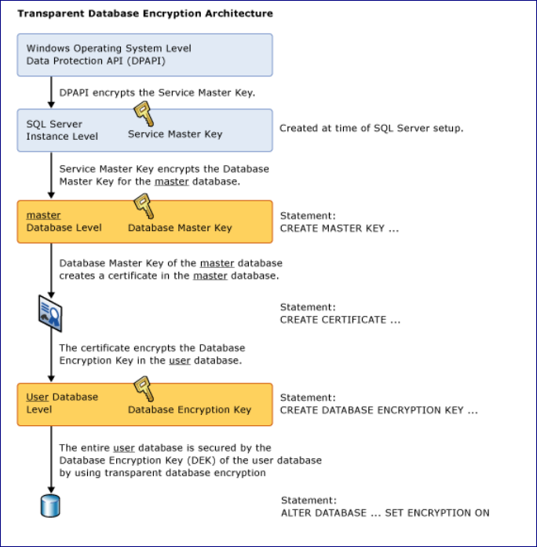

Database encryption need a proper planning. Let’s see how we can implement encryption in database.
CREATE MASTER KEY, DATABASE KEY, CERTIFICATE and ENABLE ENCRYPTION
1.Creation of master Key:
CREATE MASTER KEY ENCRYPTION BY PASSWORD = '@Password1'
2.Link database master key and service master key (important step):
OPEN MASTER KEY DECRYPTION BY PASSWORD = '@Password1'

ALTER MASTER KEY ADD ENCRYPTION BY SERVICE MASTER KEY
3.Create certificate and symmetric key as usual:
CREATE CERTIFICATE Cert_SK_BorrowerAdmin
WITH SUBJECT = 'Certificate for accessing Borrower details for use by
admin', EXPIRY_DATE = '12/31/2100';

CREATE SYMMETRIC KEY SK_BorrowerSSN WITH
ALGORITHM = AES_256 ENCRYPTION BY CERTIFICATE Cert_SK_BorrowerAdmin
CREATE TABLE and TEST ENCRYPTION
4. Create Table and insert records.
USE [AdventureWorks2012]
GO
CREATE TABLE [dbo].[Borrower](
[Borrower_Id] [int] NOT NULL,
[Borrower_SSN] [varbinary(max)] NOT NULL)
GO
Open symmetric Key SK_BorrowerSSN
DECRYPTION by certificate Cert_SK_BorrowerAdmin
Insert into Borrower (Borrower_id, Borrower_SSN)
values (1,EncryptByKey (Key_GUID('SK_BorrowerSSN'), 'AJNPG7783Q'))
Insert into Borrower (Borrower_id, Borrower_SSN)
values (2,EncryptByKey (Key_GUID('SK_BorrowerSSN'), 'BCCPG8793Q'))
Insert into Borrower (Borrower_id, Borrower_SSN)
values (3,EncryptByKey (Key_GUID('SK_BorrowerSSN'), 'TCCERGTETA'))
GO
--VERIFY Data
Select * From Borrower
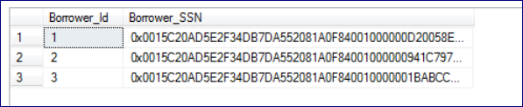

6. Select data from table:
OPEN SYMMETRIC KEY SK_BorrowerSSN
DECRYPTION BY CERTIFICATE Cert_SK_BorrowerAdmin;
GO
-- Now list the original Borrower_SSN, the encrypted ID
SELECT Borrower_Id, Borrower_SSN AS 'Encrypted SSN Number',
CONVERT(varchar, DecryptByKey(Borrower_SSN)) AS 'Decrypted SSN Number'
FROM dbo.Borrower;
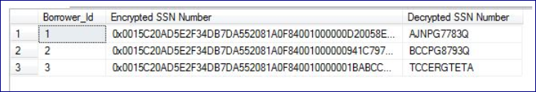
Now you have setup encryption on table and you are able to save the data in encrypted format and decrypt it back with Valid Key in place. But other users will not be able to view detail unless you provide Decrypt and read data permission. To grant decrypt and read permission run below command.
GRANT VIEW DEFINITION ON SYMMETRIC KEY::SK_BorrowerSSN TO test;
GO
GRANT VIEW DEFINITION ON Certificate::Cert_SK_BorrowerAdmin TO test;
GO
ADMINISTRATION – BACKUP And RESTORE ENCRYPTION KEY
Now we will see how we can backup the encryption Service Master key and Database master key, restore it to different server when we move DB.
7.Backup master key :
BACKUP SERVICE MASTER KEY TO FILE = 'D:\EncryptionBackup\
ServiceMasterKey1'
ENCRYPTION BY PASSWORD = '@Password3';

5.Back up database master key:
BACKUP MASTER KEY TO FILE = 'D:\EncryptionBackup\MasterKey1'
ENCRYPTION BY PASSWORD = '@Password2';
6.Restore Database: (In case of disaster – Required)
Just restore the database backup to the destination server and link database master key to service master key using following command in the destination database.
OPEN MASTER KEY DECRYPTION BY PASSWORD = '@Password1'
ALTER MASTER KEY ADD ENCRYPTION BY SERVICE MASTER KEY
Now you should be able to decrypt any data encrypted in the database.
No need to restore the Service Master key and Master Key to get database up and running on another server.
7.Restore Keys: (In case of disaster – Optional)
Do not use following commands unless required. Step 6 is sufficient to move database to another server.
RESTORE MASTER KEY FROM FILE = 'D:\EncryptionBackup\MasterKey1'
DECRYPTION BY PASSWORD ='@Password2'
ENCRYPTION BY PASSWORD ='@Password1'
GO

RESTORE SERVICE MASTER KEY FROM FILE = 'D:\EncryptionBackup\
ServiceMasterKey1'
DECRYPTION BY PASSWORD = '@Password3' FORCE
GO

OPEN MASTER KEY DECRYPTION BY PASSWORD ='@Password1'
ALTER MASTER KEY ADD ENCRYPTION BY SERVICE MASTER KEY
GO
Now go ahead, enable encryption for your Database and let me know your comments, challenges you face.

